3) Inter-LAN Communication Using DHCP and Static Routing
Objective: To configure two routers with DHCP services, establish communication between two different LANs using static routing

Theory
Dynamic Host Configuration Protocol (DHCP) is a network management protocol that automatically assigns IP addresses and other network parameters such as subnet mask, default gateway, and DNS server to client devices. This eliminates the need for manual IP configuration, reduces configuration errors, and simplifies network administration. Each router can act as a DHCP server by maintaining a DHCP pool from which client devices obtain their network configuration dynamically.
When multiple LANs are connected through routers, devices on different networks cannot communicate unless routing information is available. Static routing is a routing method in which network administrators manually configure routes to remote networks. Each router stores these routes in its routing table and forwards packets through the specified next-hop address. Static routing is suitable for small networks because it is simple, secure, and consumes minimal network resources. The successful exchange of packets can be verified using routing table inspection, ping tests, and Packet Tracer simulation mode.
DHCP address allocation process
- Discover – The client broadcasts a request to locate a DHCP server.
- Offer – The DHCP server responds with an available IP address and network configuration.
- Request – The client requests the offered IP address from the server.
- Acknowledge (ACK) – The DHCP server confirms the lease and assigns the IP address to the client.

Static Routing
Static routing is a method of configuring network routes manually on a router. Unlike dynamic routing protocols, static routes are not learned automatically; the network administrator must define the destination network, subnet mask, and next-hop router.
General Command:
ip route <Destination Network> <Subnet Mask> <Next Hop IP>

Components Required
- Two Router 2901
- Two Switch 2960
- Four PCs/Laptops (Two in each LAN)
- Copper Straight-Through Cable
- Cisco Packet Tracer

Procedure

1. Creating the Network Topology
i) Open Cisco Packet Tracer.
ii) Place the following devices in the workspace:
- 2 Routers
- 2 Switches
- 4 PCs
iii) Connect each router to its respective switch using Copper Straight-Through cables.
iv) Connect the two routers using GigabitEthernet interfaces.
v) Connect the PCs to their respective switches.
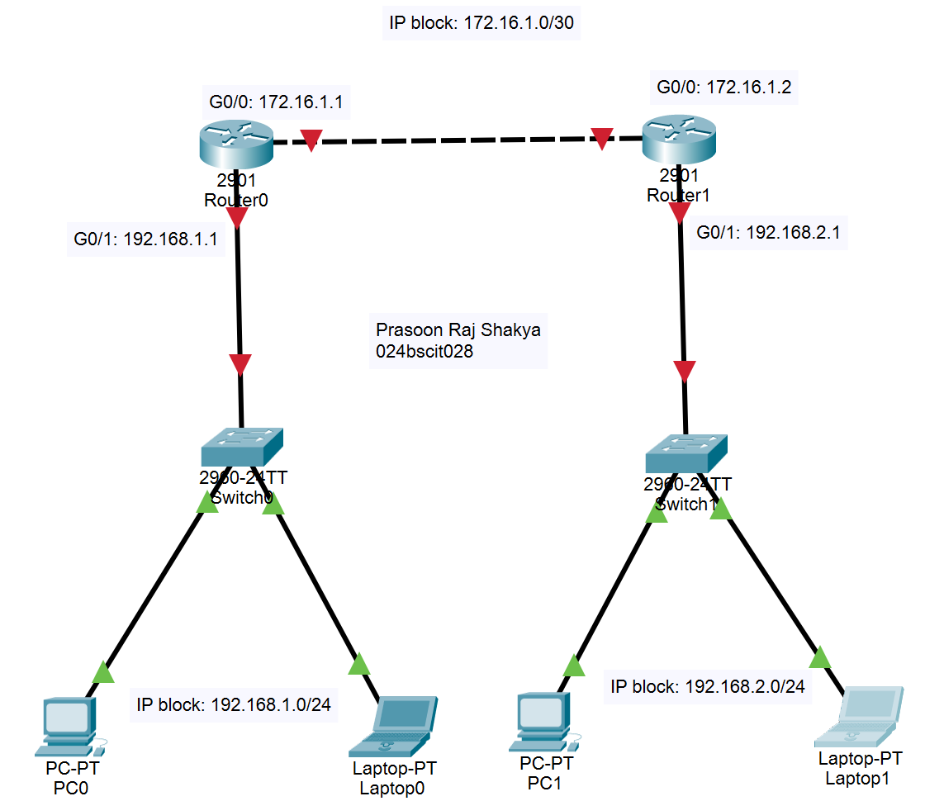

2. Configuring Router 0
i) Enter privileged EXEC mode and global configuration mode.
ii) Configure the router hostname as Prasoon_R0.
iii) Assign IP addresses to the interfaces:
- GigabitEthernet0/0 → 172.16.1.1/30
- GigabitEthernet0/1 → 192.168.1.1/24
iv) Enable both interfaces using the no shutdown command.
CLI:
Router>en
Router#conf t
Enter configuration commands, one per line. End with CNTL/Z.
Router(config)#hostname Prasoon_R0
Prasoon_R0(config)#interface gigabitEthernet0/0
Prasoon_R0(config-if)#ip address 172.16.1.1 255.255.255.252
Prasoon_R0(config-if)#no shutdown

Prasoon_R0(config-if)#
%LINK-5-CHANGED: Interface GigabitEthernet0/0, changed state to up

Prasoon_R0(config-if)#exit
Prasoon_R0(config)#interface gigabitEthernet0/1
Prasoon_R0(config-if)#ip address 192.168.1.1 255.255.255.0
Prasoon_R0(config-if)#no shutdown

Prasoon_R0(config-if)#
%LINK-5-CHANGED: Interface GigabitEthernet0/1, changed state to up

%LINEPROTO-5-UPDOWN: Line protocol on Interface GigabitEthernet0/1, changed state to up

Prasoon_R0(config-if)#exit

v) Configure a DHCP pool named LAB_A with:
- Network: 192.168.1.0/24
- Default Gateway: 192.168.1.1
- DNS Server: 10.10.10.10

CLI:
Prasoon_R0(config)#ip dhcp pool LAB_A
Prasoon_R0(dhcp-config)#net
Prasoon_R0(dhcp-config)#network 192.168.1.0 255.255.255.0
Prasoon_R0(dhcp-config)#default-router 192.168.1.1
Prasoon_R0(dhcp-config)#dns-server 10.10.10.10
Prasoon_R0(dhcp-config)#exit
Prasoon_R0(config)#exit
Prasoon_R0#
%SYS-5-CONFIG_I: Configured from console by console
Prasoon_R0#wr
Building configuration...
[OK]
vi) Save the router configuration.

3. Configuring Router 1
i) Configure the hostname as Prasoon_R1.
ii) Assign IP addresses to the interfaces:
- GigabitEthernet0/0 → 172.16.1.2/30
- GigabitEthernet0/1 → 192.168.2.1/24
iii) Enable both interfaces.
CLI:
Router>en
Router#conf t
Enter configuration commands, one per line. End with CNTL/Z.
Router(config)#hostname Prasoon_R1
Prasoon_R1(config)#interface gigabitEthernet0/0
Prasoon_R1(config-if)#ip address 172.16.1.2 255.255.255.252
Prasoon_R1(config-if)#no shutdown
Prasoon_R1(config-if)#
%LINK-5-CHANGED: Interface GigabitEthernet0/0, changed state to up
%LINEPROTO-5-UPDOWN: Line protocol on Interface GigabitEthernet0/0, changed state to up
Prasoon_R1(config-if)#exit
Prasoon_R1(config)#interface gigabitEthernet0/1
Prasoon_R1(config-if)#ip address 192.168.2.1 255.255.255.0
Prasoon_R1(config-if)#no shutdown
Prasoon_R1(config-if)#
%LINK-5-CHANGED: Interface GigabitEthernet0/1, changed state to up
%LINEPROTO-5-UPDOWN: Line protocol on Interface GigabitEthernet0/1, changed state to up
Prasoon_R1(config-if)#exit
iv) Configure a DHCP pool named LAB_B with:
- Network: 192.168.2.0/24
- Default Gateway: 192.168.2.1
- DNS Server: 20.20.20.20
CLI:
Prasoon_R1(config)#ip dhcp pool LAB_B
Prasoon_R1(dhcp-config)#network 192.168.2.0 255.255.255.0
Prasoon_R1(dhcp-config)#default-router 192.168.2.1
Prasoon_R1(dhcp-config)#dns-server 20.20.20.20
Prasoon_R1(dhcp-config)#exit
Prasoon_R1(config)#exit
Prasoon_R1#
%SYS-5-CONFIG_I: Configured from console by console
Prasoon_R1#wr
Building configuration...
[OK]
v) Save the configuration.

4. Verifying DHCP Address Allocation
i) Configure all PCs to obtain IP addresses automatically using DHCP.
ii) Verify that:
- Clients in LAN 1 receive addresses from the 192.168.1.0/24 network.
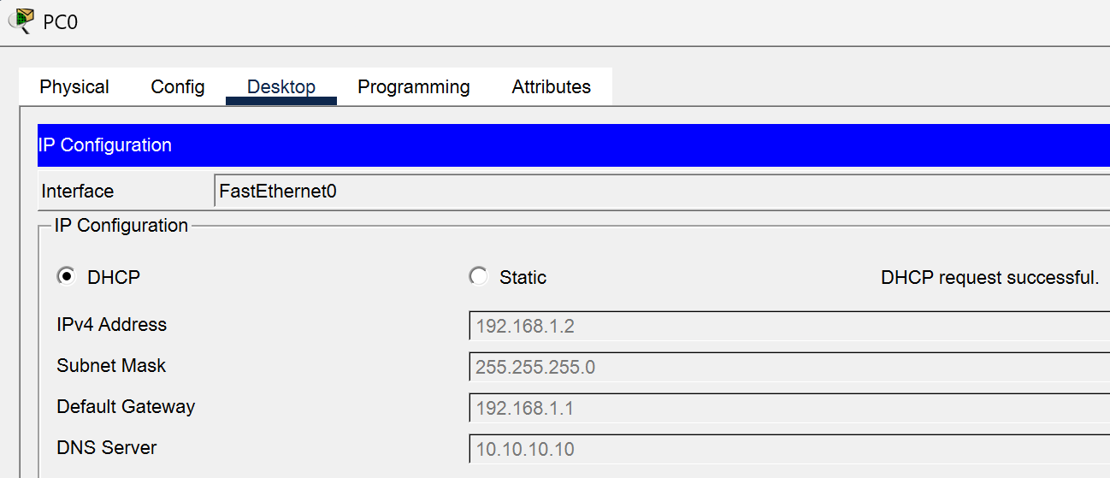
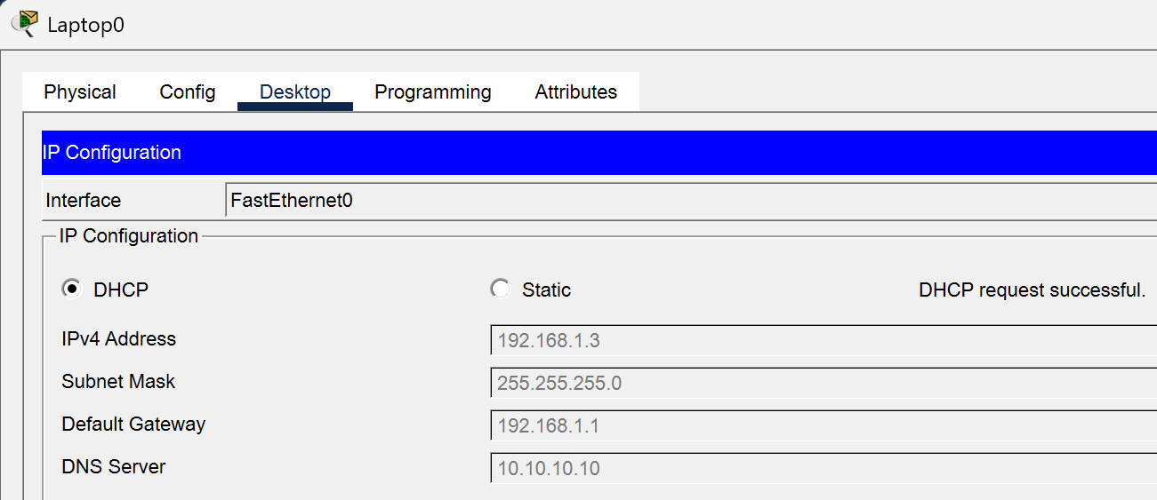
- Clients in LAN 2 receive addresses from the 192.168.2.0/24 network.
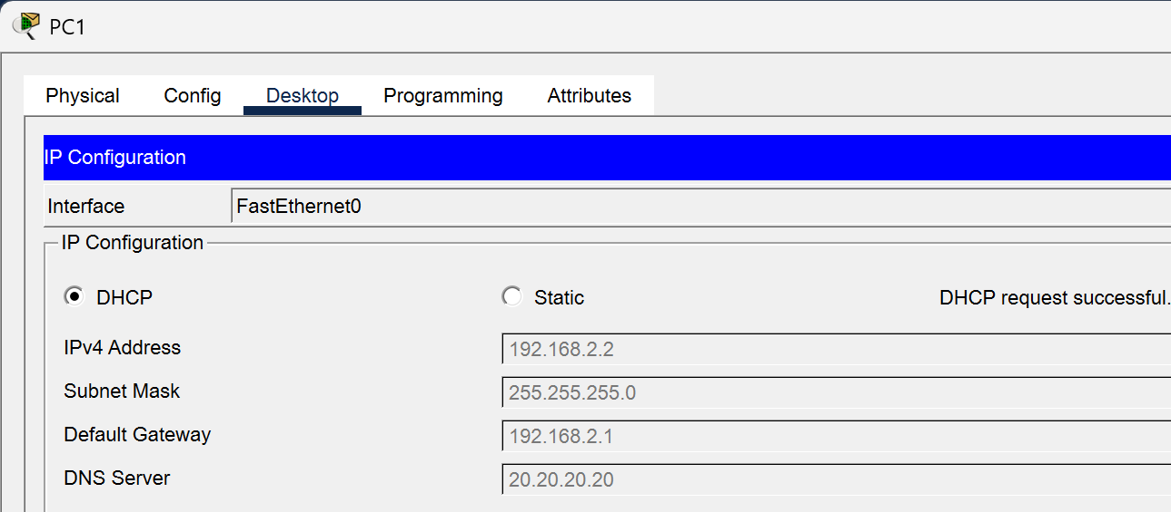
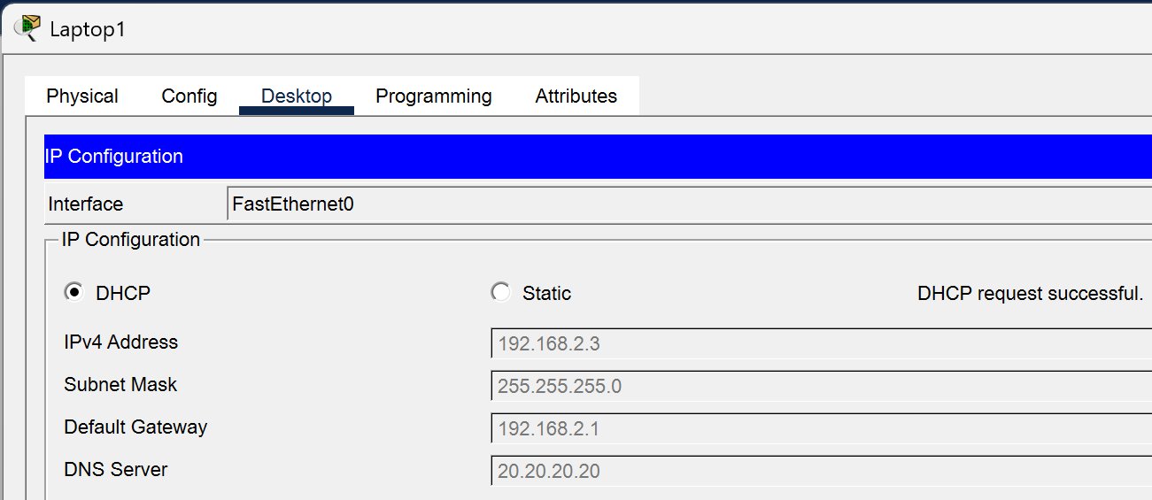
iii) Confirm that each client receives the correct default gateway and DNS server.

5. Checking Gateway Connection
Inside LAN:
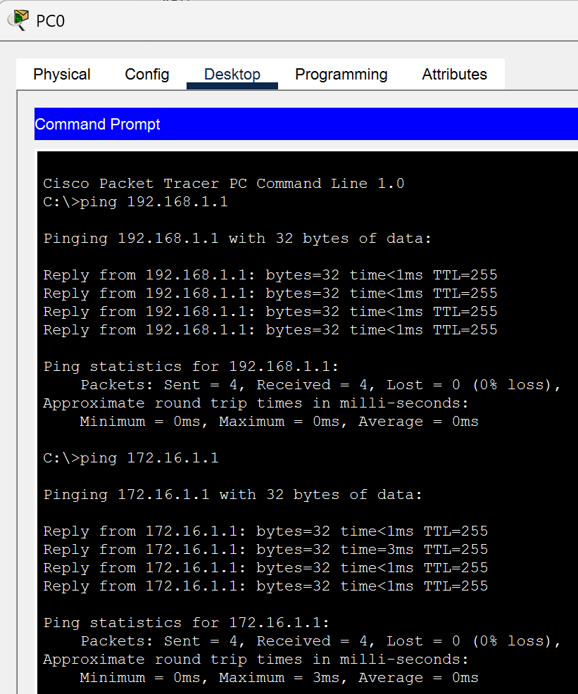 | SUCCESS
Router-to-Router
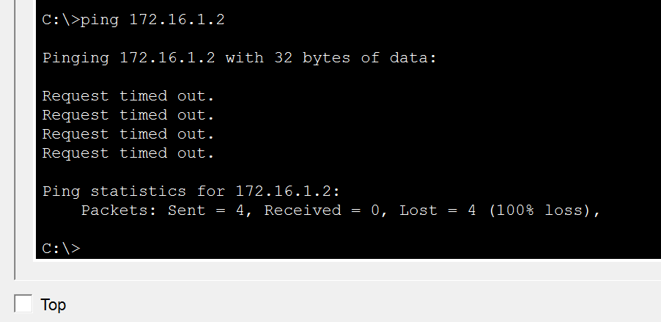 | FAILURE  *Routing required

6. Configuring Static Routing
i) On Router 0, configure a static route to reach LAN 2:
ip route 192.168.2.0 255.255.255.0 172.16.1.2
ii) On Router 1, configure a static route to reach LAN 1:
ip route 192.168.1.0 255.255.255.0 172.16.1.1
iii) Verify the routing tables using: show ip route. Ensure that the static routes (S) appear in both routing tables.
Router0:
Prasoon_R0#show ip route
Codes: L - local, C - connected, S - static, R - RIP, M - mobile, B - BGP
D - EIGRP, EX - EIGRP external, O - OSPF, IA - OSPF inter area
N1 - OSPF NSSA external type 1, N2 - OSPF NSSA external type 2
E1 - OSPF external type 1, E2 - OSPF external type 2, E - EGP
i - IS-IS, L1 - IS-IS level-1, L2 - IS-IS level-2, ia - IS-IS inter area
* - candidate default, U - per-user static route, o - ODR
P - periodic downloaded static route
Gateway of last resort is not set
172.16.0.0/16 is variably subnetted, 2 subnets, 2 masks
C 172.16.1.0/30 is directly connected, GigabitEthernet0/0
L 172.16.1.1/32 is directly connected, GigabitEthernet0/0
192.168.1.0/24 is variably subnetted, 2 subnets, 2 masks
C 192.168.1.0/24 is directly connected, GigabitEthernet0/1
L 192.168.1.1/32 is directly connected, GigabitEthernet0/1
S 192.168.2.0/24 [1/0] via 172.16.1.2
Prasoon_R0#
Router1:
Prasoon_R1#show ip route
Codes: L - local, C - connected, S - static, R - RIP, M - mobile, B - BGP
D - EIGRP, EX - EIGRP external, O - OSPF, IA - OSPF inter area
N1 - OSPF NSSA external type 1, N2 - OSPF NSSA external type 2
E1 - OSPF external type 1, E2 - OSPF external type 2, E - EGP
i - IS-IS, L1 - IS-IS level-1, L2 - IS-IS level-2, ia - IS-IS inter area
* - candidate default, U - per-user static route, o - ODR
P - periodic downloaded static route
Gateway of last resort is not set
172.16.0.0/16 is variably subnetted, 2 subnets, 2 masks
C 172.16.1.0/30 is directly connected, GigabitEthernet0/0
L 172.16.1.2/32 is directly connected, GigabitEthernet0/0
S 192.168.1.0/24 [1/0] via 172.16.1.1
192.168.2.0/24 is variably subnetted, 2 subnets, 2 masks
C 192.168.2.0/24 is directly connected, GigabitEthernet0/1
L 192.168.2.1/32 is directly connected, GigabitEthernet0/1
Prasoon_R1#

6. Testing Connectivity
i) Verify communication between the routers using the ping command.
ii) Ping the remote LAN gateway from Router 1.
iii) Test communication between a PC in LAN 1 and a PC in LAN 2.
iv) Confirm that all ping requests receive successful replies.
CLI:
Prasoon_R1#ping 172.16.1.1
Type escape sequence to abort.
Sending 5, 100-byte ICMP Echos to 172.16.1.1, timeout is 2 seconds:
!!!!!
Success rate is 100 percent (5/5), round-trip min/avg/max = 0/0/0 ms
Prasoon_R1#
Prasoon_R1#ping 192.168.1.1
Type escape sequence to abort.
Sending 5, 100-byte ICMP Echos to 192.168.1.1, timeout is 2 seconds:
!!!!!
Success rate is 100 percent (5/5), round-trip min/avg/max = 0/0/0 ms
Prasoon_R1#

Command Prompt:
Router-to-Routers
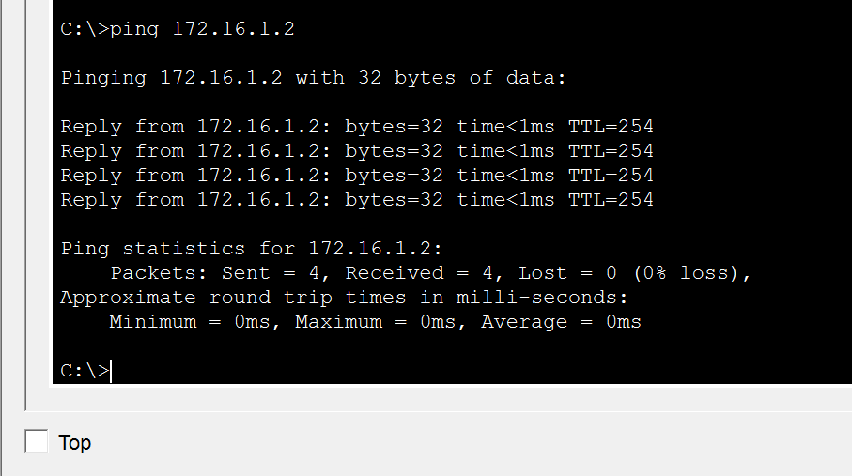 | SUCCESS

Inter-LAN communication(PC0->PC1)
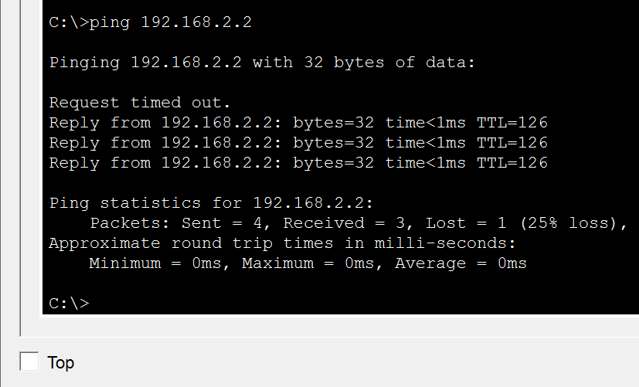 | SUCCESS

7. Simulation Verification
i) Switch Cisco Packet Tracer to Simulation Mode.
ii) Generate network traffic by pinging a PC in LAN 1 from a PC in LAN 2.
iii) Observe DHCP address allocation and packet forwarding through both routers.
iv) Verify successful end-to-end communication across both LANs.
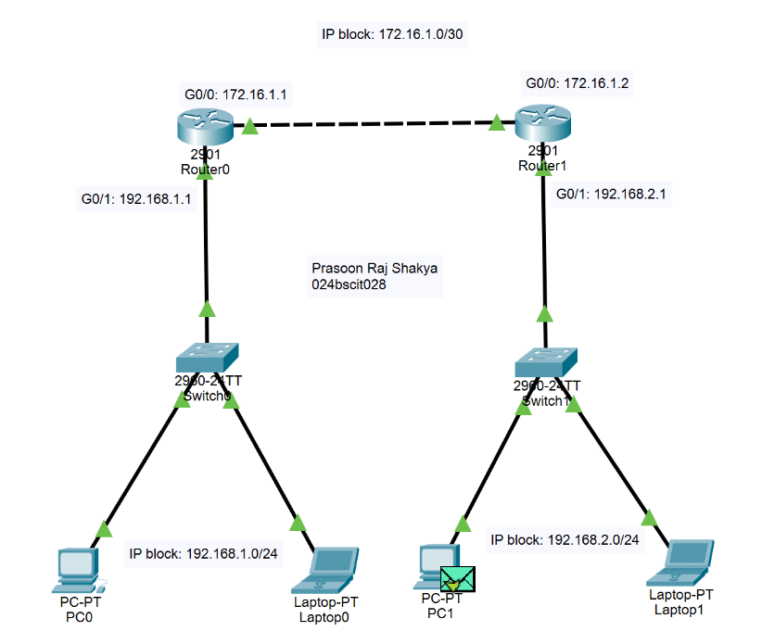
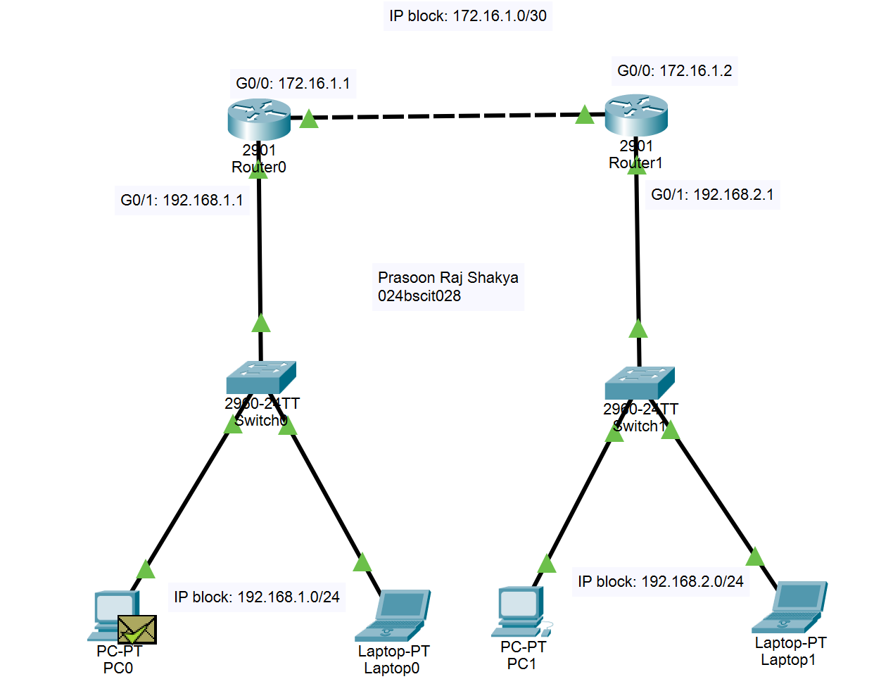
Conclusion
In this laboratory exercise, two LANs were configured using routers that acted as DHCP servers to provide automatic IP address allocation to client devices. Static routes were then configured on both routers to enable communication between the two separate networks. Verification through routing tables, successful ping tests, and Packet Tracer simulation confirmed that inter-LAN communication was established correctly. The experiment demonstrated the combined use of DHCP and static routing to build a functional routed network.

